A Project Report On

[Royal Furniture]

The Report Submitted To

SAURASHTRA UNIVERSITY



Submitted In Partial Fulfilment of The RequirementFor The Award of The Degree

Academic Year 2022-2023

**BACHELOR OF COMPUTER APPLICATION**

**[Semester – 5th]**

**Prepared By:-**

**[Shivam Rangani]**

**[Dwarkesh Dedaniya]**





Int.project guidance:-prof.[Poonam Shingala]

PREFACE

There is a wide difference between theoretical and practical knowledge and to understand that different for the use of knowledge. Project Report is new and interesting experience for us. We say it is difficult from particular we came to know about the the oretical ideas of the matter and its dealing. Project Report helps to build sin our life.

By preparing this report, we have understood the need of practical training in the education field. It is easier to work with computerized system the manual system. It saves time , effort and space and increases the efficiency by creating interest.

Our project is with respect to “Royal Furniture”. The Project Report contains the information regarding information about Online Shopping.

The concerned people who were connected with our project were very keen in their work and provided us with all the useful information. The response from them was very positive and they were very informal to us.

This project is part of our fifth Semester of BCA Course Curriculum. We here by declare that it is our own work with guidance of the faculty members of our college.

ACKNOWLEDGEMENT

Our website, which you are using, is the result of many people’s dedication. The cumulative efforts of many minds working to get his day and night gave us the contentment of developing the software. Special thanks to Grace College for great support.

We express our gratitude to for guidance and who kept the things on track and to all other faculty members who helped us directly or indirectly.

Finally yet importantly, our acknowledgement goes to all the well-wishers of our project his excellent support in all aspects.

DECLARATION

I hereby declare that this project work entitled **ONLINE SHOPPING PORTAL** is record done

by me.

I also declare that the matter embodied in this project is genuine work done by me and has not been submitted whether to this University or to any other University /Institute for the Fulfilment of the requirement of any course of study.

Place:-

Date:-

**PAGE INDEX**

**Certificate……………………..……………………………………………………………………….....** **Acknowledgement ………………………………………………………………………………….... List of Tables ………………………………………………………………………………….……….... Notation & Abbrevations ……………………………………………………………….………....**

1. **Introduction**
   1. Project Summery with details
   2. Objective/ Scope
   3. Project Boundary
2. **Literature Survey**
   1. PHP Overview
   2. HTML Overview
   3. CSS Overview
   4. Bootstrap Overview
   5. JAVASCRIPT Overview
   6. MYSQL Overview
3. **Project Management**
   1. Project Planning and Scheduling [SDLC]
   2. Schedule Representation week or Month wise
4. **Requirement Specification**
   1. Hardware Requirements
   2. Software Requirements
   3. Function Requirements
5. **System Design**
   1. Basic Flow of System
      1. Use Case Diagram
      2. Data Flow Diagram
   2. Context Level Diagram
   3. E-R Diagram
6. **Implementation**
   1. Data Dictionary
   2. Screen Shot with Description
7. **Testing**
   1. Testing
   2. **Testing Level**
      1. Unit Testing
      2. Integration Testing
      3. System Testing
      4. Validation Testing
8. **Future Work**
9. **Conclusion**
10. **References & Bibliography**

**List of Tables**

|  |  |
| --- | --- |
| **No** | **Table Name** |
| 1 | [**rf_admin**](http://localhost/phpmyadmin/sql.php?db=royal_furniture&table=rf_admin&pos=0) |
| 2 | [**rf_cart**](http://localhost/phpmyadmin/sql.php?db=royal_furniture&table=rf_cart&pos=0) |
| 3 | [**rf_categories**](http://localhost/phpmyadmin/sql.php?db=royal_furniture&table=rf_categories&pos=0) |
| 4 | [**rf_contact**](http://localhost/phpmyadmin/sql.php?db=royal_furniture&table=rf_contact&pos=0) |
| 5 | [**rf_orders**](http://localhost/phpmyadmin/sql.php?db=royal_furniture&table=rf_orders&pos=0) |
| 6 | [**rf_order_items**](http://localhost/phpmyadmin/sql.php?db=royal_furniture&table=rf_order_items&pos=0) |
| 7 | [**rf_products**](http://localhost/phpmyadmin/sql.php?db=royal_furniture&table=rf_products&pos=0) |
| 8 | [**rf_users**](http://localhost/phpmyadmin/sql.php?db=royal_furniture&table=rf_users&pos=0) |

**1**

# INTRODUCTION

## Project Summery

* + - Our Project is Web Development, developed for Gorgeous You.
    - In an existing system, user should go to Visit Website and get information and more detail about the other facilities So visitors should get better results from Products. It is main drawback of the existing system.
    - The application is reduced as much as possible to avoid errors while entering the data. It also provides error message while entering invalid data. No formal knowledge is needed for the user to use this system. Thus by this all it proves it is user-friendly. Gorgeous You, as describe above, can lead to error free, secure, reliable and fast management system.
    - It can assist the user to concentrate on their other activities rather to concentrate on the record keeping. Thus it will help organization in better utilization of resources.
    - The Website is developed in PHP (XAMPP Server), HTML, JavaScript and MySQL for the Database.
    - The Website maintains the data of the user and it’s searching results for the Product.

## Objective/Aim/ Scope

* + - Online Om Electronics System is a user friendly contact and online shopping website. Save time and sell more by empowering to easily keep track of leads, manage listings, and market to new prospects.
    - Shopping site gives you a clear view of what is going on in your business and provides simple steps that your team can easily follow to help grow your business. Take your business to the next level and stop wasting time with outdated or inefficient practices. Women’s Clothing item has powerful search and match facility to match other item with buyer by the selection parameter, related image and description.
    - The aims of the project are to determine the suitable needs and requirements to design item etc. website. The primary goal of the

application is to connect the agencies with the clients, providing them with the up-to date information of the available fashion . The project combines datasets and various knowledge and interpretation tools from the online shopping industry to provide images of, and characterize resources. By using the website, clients can upload information about their estates, while potential customers can visually search for an estate and take a look of its surrounding, the exterior and the interior

## Scope

* + - **Language Scope:**
      * Language – PHP , HTML , CSS , BOOTSTRAP ,

JAVASCRIPT , MYSQL Connectivity

* + - **Project Scope:**
      * The scope of the project is defining what will and will not be supported by the website. This website will enable servers to manage accounts: upload photos, fill out and submit offers and advertisements, including short text descriptions, as well as register for an online shopping and offers for auctioned estates. On the other hand, it will also enable online shopping website text descriptions and schedule item. In its current stage of development, it is not planned for the website to support.

## Project Boundary

* Require XAMPP web server

## Duration

* + - In 16 weeks my website will be completed. Analysis: 4 weeks

Design: 3 weeks

Coding: 6 weeks

Testing: 3 weeks

**2**

# LITERATURE SURVEY

## PHP Overview:

* + - The full form of PHP is “Hypertext Preprocessor”. Its original name was “Personal Home Page”.
    - Rasmus Lerdorf software engineer, Apache team member is the creator and original driving force behind PHP. The first part of PHP was developed for his personal use in late 1994.
    - By the middle of 1997, PHP was being used on approximately 50,000 sites worldwide.
    - PHP is server-side scripting language, which can be embedded in HTML or used as a stand-alone.
    - PHP doesn’t do anything about what a page looks and sounds like. In fact, most of what PHP does is invisible to the end user.
    - Someone looking at a PHP page will not necessarily be able to tell that it was not written purely in HTML, because usually the result of PHP is HTML.
    - PHP is an official module of Apache HTTP Server.
    - PHP is fully cross-platform, meaning it runs native on several flavors of UNIX, as well as on Windows and now on Mac OS X.
    - **Advantages Of PHP:**
      * ***Cost*:** PHP costs you nothing. It is open source software and doesn’t need to purchase it for development.
      * ***Ease of Use*:** PHP is easy to learn, compared to the others. A lot of Ready-made PHP scripts are freely available in market so, you can use them in your project or get some help from them.
      * ***HTML- Support:*** PHP is embedded within HTML; In other words, PHP pages are ordinary HTML pages that escape into PHP mode only when necessary. When a client requests this page, the web server preprocesses it. This means it goes through the page from top to bottom, looking for sections of PHP, which it will try to resolve.
      * ***Cross-platform compatibility*:** MySQL run native on every popular flavor of UNIX and windows. A huge percentage PHP and of the world’s HTTP servers run on one of these two classes of operating system.
      * **Speed:** PHP is pleasingly zippy in its execution, especially when compiled as an Apache module on the UNIX side. Although it takes a slight performance hit by being interpreted rather than compiled, this is far outweighed by the benefits PHP drives from its status as a Web server module.

## HTML Overview:

* + - HTML was originated by Tim Berners-Lee
    - HTML developed a few years ago as a subset of SGML (Standard Generalized Mark-up Language), which is a higher-level mark-up language that has long been a favorite of the Department of Defense.
    - Any HTML document is also valid for SGML
    - HTML is a Hyper Text Markup Language that is used to develop web pages
    - HTML is not a programming language like C, C++ and Java etc.
    - It is a cross platform markup language that is design to be flexible enough to display text and other elements like graphical on a variety of views.
    - The HTML documents consist of special Tags that are embedded in an ASCII document.
    - Web browser like Internet Explorer, Netscape Navigator etc, interprets these Tags.

## CSS Overview:

* + - CSS stands for Cascading Style Sheets
    - CSS describes how HTML elements are to be displayed on screen, paper, or in other media
    - CSS saves a lot of work. It can control the layout of multiple web pages all at once
    - External stylesheets are stored in CSS files

## BOOTSTRAP Overview:

* + - **Bootstrap** is a free and open-source CSS framework directed at responsive, mobile-first front-end web development. It contains CSS- and (optionally) JavaScript-based design templates for typography, forms, buttons, navigation, and other interface components.
    - Bootstrap is the seventh-most-starred project on GitHub , with more than 142,000 stars, behind freeCodeCamp (almost 312,000 stars) and marginally behind Vue.js framework.
    - Bootstrap, originally named Twitter Blueprint, was developed by Mark Otto and Jacob Thornton at Twitter as a framework to encourage consistency across internal tools. Before Bootstrap, various libraries were used for interface development, which led to inconsistencies and a high maintenance burden. According to Twitter developer Mark Otto.

## JAVASCRIPT Overview :

* + - JavaScript was designed to add interactivity to HTML pages.
    - JavaScript is a scripting language (a scripting language is a lightweight programming language)
    - A JavaScript consists of lines of executable computer code
    - A JavaScript is usually embedded directly into HTML pages
    - JavaScript is an interpreted language (means that scripts execute without preliminary compilation)
    - Everyone can use JavaScript without purchasing a license.

## MYSQL Overview :

* + - **MYSQL DATABASE MANAGEMENT SYSTEM :**
      * MySQL, the most popular Open Source SQL database management system, is developed, distributed, and supported by MySQL.
      * MySQL is a commercial company, founded by the MySQL developers. It is a second generation Open Source Company that unites Open Source values and methodology with a successful business model.
      * The MySQL Web site (<http://www.mysql.com/)> provides the latest information about MySQL software and MySQL.
      * The official way to pronounce “MySQL” is “My Ess Que Ell” (not “my sequel”), but we don't mind if you pronounce it as “my sequel” or in some other localized way.
* **MYSQL FEATURES :**
  + MySQL, the most popular Open Source SQL database management system, is developed, distributed, and supported by MySQL.
  + MySQL is a commercial company, founded by the MySQL developers. It is a second generation Open Source Company that unites Open Source values and methodology with a successful business model.
  + The MySQL Web site ([http://www.mysql.com/)](http://www.mysql.com/) provides the latest information about MySQL software and MySQL.
  + The official way to pronounce “MySQL” is “My Ess Que Ell” (not “my sequel”), but we don't mind if you pronounce it as “my sequel” or in some other localized way.

**2.5) Analysis :**

* When I started My Project First of all I had seen Software Download Web Sites Like [www.girawalatours.com,](http://www.girawalatours.com/) [www.gandhitour.com](http://www.gandhitour.com/) [e](http://www.gandhitour.com/)tc. And seen their Facility which they provide.
* Then i collected the Information about tours and travels Web Sites then I collect information which i want for my Website. I have given following facilities in My website.
* Client Side:
  + Registration
  + Login
  + Contact
  + About us
  + User can see Product & Product details
  + User can add product in cart
* Admin Side :
  + Add, Edit, Delete Category
  + Add, Edit, Delete Product
  + Show the Category list
  + Show the Product list
  + Show The Contact’s list

**3**

# PROJECT MANAGEMENT

* 1. **Project Planning and Scheduling :**
     + **Software Development Process : Waterfall Model**
       - In the waterfall model, a project progresses through an orderly sequence of steps from the initial software concept through system testing. The project holds a review at the end of each phase to determine whether it is ready to advance to the next phase - from requirements analysis to architectural design. If the review determines that the project isn't ready to move to the next phase, it stays in the current phase until it is ready.
       - The waterfall model is document driven, which means that the main work products that are carried from phase to phase are documents. In the pure waterfall model, the phases are also discontinuous - they do not overlap. The following shows how the pure waterfall lifecycle model progresses.
       - The pure waterfall model performs well for product cycles in which you have a stable product definition and when you're working with wellunderstood technical methodologies. In such cases, the waterfall model helps you to find errors in the early, low-cost stages of a project. It provides the requirement stability that developers crave. If you're building a well-defined maintenance release of an existing product or porting an existing product to a new plat. Form, a waterfall lifecycle might be the right choice for rapid development.
       - The pure waterfall model helps to minimize planning overhead because you can do all the planning up front. It doesn't provide tangible results in the form of software until the end of the lifecycle, but, to someone who is familiar with it, the documentation it generates provides meaningful progress throughout the lifecycle.

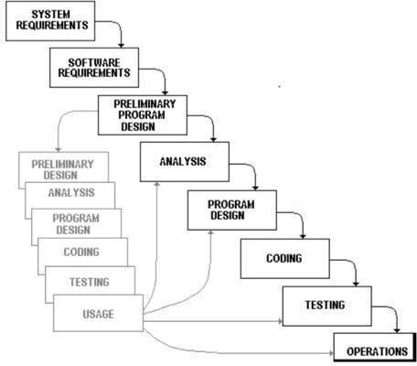

* 1. **Schedule Representation week or Month wise :**

|  |  |  |
| --- | --- | --- |
| **System Analysis** | **Duration** | **Resource Requirement** |
| System Design and  Documentation | 3 WEEKS | All |
| Actual Development | 2 WEEKS | All |
| Unit Testing | 2 WEEKS | All |
| Integrated of System | 2 WEEKS | All |
| Test case preparation | 3 WEEKS | All |
| System Testing | 3 WEEKS | All |
| Bug Fixing | 1 WEEKS | All |

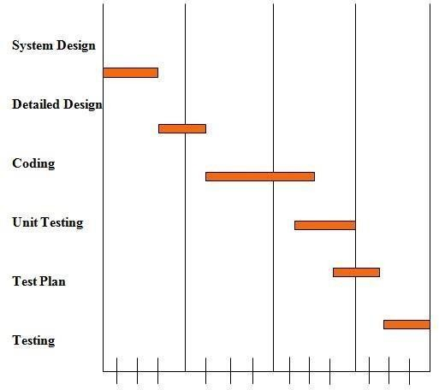

**4**

# REQUIREMENTS SPECIFICATION

* 1. **HARDWARE REQUIREMENTS :**
     + Pentium –IV Processor 550 MHz or Above
     + Minimum 80 GB Hard disk
     + Minimum 256 MB RAM Mouse, Keyboard
     + 4x CR-ROM drive OR USB port
  2. **SOFTWARE REQUIREMENTS :**
     + Windows XP, 7, 8, 10
     + Mozilla Fire Fox latest version
     + Xammp web server latest version or wampp server
     + PHP 5.6.3
     + MySQL 5.5.32
     + Microsoft word
     + Macromedia Dreamweaver

**5**

# SYSTEM DESIGN

* 1. **Basic Flow Of System :**
     1. **Use Case Diagram :**
        + **User**

Login

Regsiter

Home

Search Product

User

Product Detail

Add To Cart

Contact Us

About Us

Logout

* + - * **Admin**

Login

Admin

Manage Product

Manage Category

Manage Orders

Manage Contact Data

Manage User

* + 1. **Data Flow Diagram :**
       - **What Is Data Flow Diagrams (DFD) ?**
         * Data flow diagrams are commonly used for understanding the system and can be effectively used for analysis. When you are designing an application system, you must first consider the flow of the data into the out of it. A DFD shows the flow of the data through a system. DFD does not show decision or timing of events.

Process to store data



Registration

Registration

Login

Verify by login table

Login

Valid

Home Page

Category

Home page

Show the list of products

Project

database

Add to cart

Product detail

Register event

Logout

* **Admin side**



Product page



Product

Category

Contact



Login

Table

Add, Delete, Edit

Dashbord

Admin



Logout

Category page

* 1. **Context Level Diagram:**

Send Query

Royal

Furniture

Up/Down Info

Receive Query

Other Info

Royal

Furniture

Admin

User

**5.2) ER Diagram**

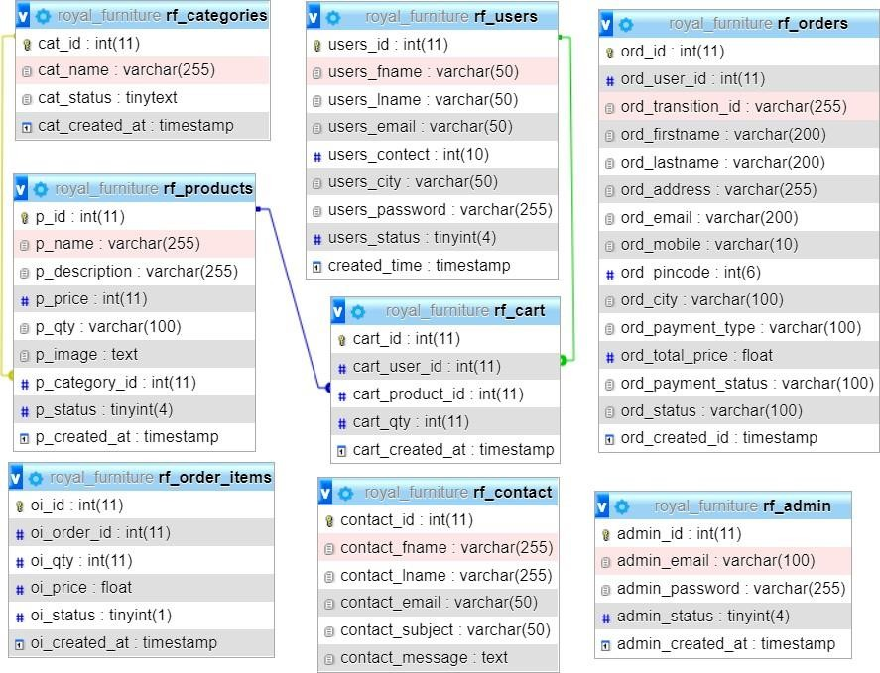

**6**

# IMPLEMENTATION

* 1. **Data Dictionary :**
     + **Database With Description**

**Users Table**

|  |  |  |  |  |
| --- | --- | --- | --- | --- |
| Table Name | | [**rf_users**](http://localhost/phpmyadmin/sql.php?db=royal_furniture&table=rf_users&pos=0) | | |
| Description | | This table is used to maintain and store the  informationrelated to users. | | |
| Primary Keys | | Users_id | | |
| Key | Field Name | Type | Size | Constraints |
| ❖ | **users_id** | Integer | 11 | Not Null ,  AUTO_INCREMENT |
|  | **users_fname** | varchar | 50 | Not Null |
|  | **users_lname** | varchar | 50 | Not Null |
|  | **users_email** | varchar | 50 | Not Null |
|  | **users_contect** | Integer | 10 | Not Null |
|  | **users_city** | varchar | 50 | Not Null |
|  | **users_password** | varchar | 255 | Not Null |
|  | **users_status** | Tinyinteger | 4 | 1 |
|  | **created_time** | timestamp |  | current_timestamp() |

**Admin Table**

|  |  |  |  |  |
| --- | --- | --- | --- | --- |
| Table Name | | Rf_admin | | |
| Description | | This table is used to maintain and store the  informationrelated to users. | | |
| Primary Keys | | **admin_id** | | |
| Foreign Keys | | - | | |
| Key | Field Name | Type | Size | Constraints |
| * | **admin_id** | Integer | 11 | Not Null , AUTO_INCREMENT |
|  | **admin_email** | Varchar | 100 | Not Null |
|  | **admin_password** | Varchar | 255 | Not Null |
|  | **admin_status** | tinyint | 4 | 1 |
|  | **admin_created_at** | timestamp | - | current_timestamp() |

**Products Table**

|  |  |  |  |  |
| --- | --- | --- | --- | --- |
| Table Name | | rf_products | | |
| Description | | This table is used to maintain and store the informationrelated to Products. | | |
| Primary Keys | | **p_id** | | |
| Foreign Keys | | **p_category_id** | | |
| Key | Field Name | Type | Size | Constraints |
| * | **p_id** | Integer | 11 | Not Null , AUTO_INCREMENT |
|  | **p_name** | text | 255 | Not Null |
|  | **p_description** | longtext | 255 | Not Null |
|  | **p_price** | int(11) | 11 | Not Null |
|  | **p_qty** | int(10) | 100 | Not Null |
|  | **p_image** | text |  | Not Null |
|  | **p_category_id** | int | 11 | Not Null |
|  | **p_status** | tinyint | 4 | 1 |
|  | **p_created_at** | timestamp |  | current_timestamp() |

**Categories Table**

|  |  |  |  |  |
| --- | --- | --- | --- | --- |
| Table Name | | rf_categories | | |
| Description | | This table is used to maintain and store the information related to category. | | |
| Primary Keys | | cat_id | | |
| Foreign Keys | | - | | |
| Key | Field Name | Type | Size | Constraints |
| * | **cat_id** | Integer | 11 | Not Null , AUTO_INCREMENT |
|  | **cat_name** | Varchar | 255 | Not Null |
|  | **cat_status** | tinytext |  | 1 |
|  | **cat_created_at** | timestamp |  | current_timestamp() |

**Contact Us Table**

|  |  |  |  |  |  |
| --- | --- | --- | --- | --- | --- |
| Table Name | | | rf_contact_us | | |
| Description | | | This table is used to maintain and store the information relatedto ContactUs. | | |
| Primary Keys | | | **contact_id** | | |
| Foreign Keys | | | - | | |
| Key | Field Name | | Type | Size | Constraints |
| * | **contact_id** |  | Integer | 11 | Not Null , AUTO_INCREMENT |
|  | |
|  | **contact_fname** | | Varchar | 255 | Not Null |
|  | **contact_lname** | | Varchar | 255 | Not Null |
|  | **contact_email** | | Varchar | 50 | Not Null |
|  | **contact_subject** | | Varchar | 255 | Not Null |
|  | **contact_message** | | text |  | Not Null |
|  | **contact_created_at** | | timestamp | **-** | current_timestamp() |

**Cart Table**

|  |  |  |  |  |
| --- | --- | --- | --- | --- |
| Table Name | | rf_cart | | |
| Description | | This table is used to maintain and store the information relatedtoCartProducts. | | |
| Primary Keys | | **cart_id** | | |
| Foreign Keys | | **cart_user_id, cart_product_id** | | |
| Key | Field Name | Type | Size | Constraints |
| * | **cart_id** | Integer | 11 | Not Null , AUTO_INCREMENT |
|  | **cart_user_id** | Integer | 11 | Not Null |
|  | **cart_product_id** | Integer | 11 | Not Null |
|  | **cart_qty** | Integer | 11 | Not Null |
|  | **cart_created_at** | timestamp | **-** | current_timestamp() |

**Order Table**

|  |  |  |  |  |  |  |
| --- | --- | --- | --- | --- | --- | --- |
| Table Name | | | | rf_orders | | |
| Description | | | | This table is used to maintain and store the information  relatedtoProductorder. | | |
| Primary Keys | | | | **ord_id** | | |
| Foreign Keys | | | | **-** | | |
| Key | Field Name | | | Type | Size | Constraints |
| * | **ord_id** | |  | Integer | 11 | Not Null , AUTO_INCREMENT |
|  | | |
|  | **ord_user_id** | | | Integer | 11 | Not Null |
|  | **ord_transition_id** | | | varchar | 255 | Not Null |
|  | **ord_firstname** | | | varchar | 200 | Not Null |
|  | **ord_lastname** | | | varchar | 200 | Not Null |
|  | **ord_address** | | | varchar | 255 | Not Null |
|  | **ord_email** | | | Varchar | 200 | Not Null |
|  | **ord_mobile** | | | Varchar | 10 | Not Null |
|  | **ord_pincode** | | | int | 6 | Not Null |
|  |  | **ord_city** | | Varchar | 100 | Not Null |
|  | | |
|  | **ord_payment_type** | | | Varchar | 100 | Not Null |
|  |  | **ord_total_price** | | float |  | Not Null |
|  | | |
|  | **ord_payment_status** | | | Varchar | 100 | Not Null |
|  | **ord_status** | | | Tinyint | 4 | 1 |
|  | **ord_created_at** | | | Timestamp | - | current_timestamp() |

**Order Item Table**

|  |  |  |  |  |  |  |
| --- | --- | --- | --- | --- | --- | --- |
| Table Name | | | | **qm_order_items** | | |
| Description | | | | This table is used to maintain and store the information  relatedtoorderItems. | | |
| Primary Keys | | | | **ord_itm_id** | | |
| Foreign Keys | | | | **-** | | |
| Key | Field Name | | | Type | Size | Constraints |
| * | **oi_id** | |  | Integer | 11 | Not Null , AUTO_INCREMENT |
|  | | |
|  | **oi_order_id** | | | Integer | 11 | Not Null |
|  | **oi_qty** | | | Integer | 11 | Not Null |
|  | **oi_price** | | | float |  | Not Null |
|  |  | **oi_status** | | Tinyint | 4 | 1 |
|  | | |
|  | **oi_created_at** | | | Timestamp | - | current_timestamp() |

* 1. **Screen Shot With Description :**
     + **Client Side :**
       - **Home Page :**

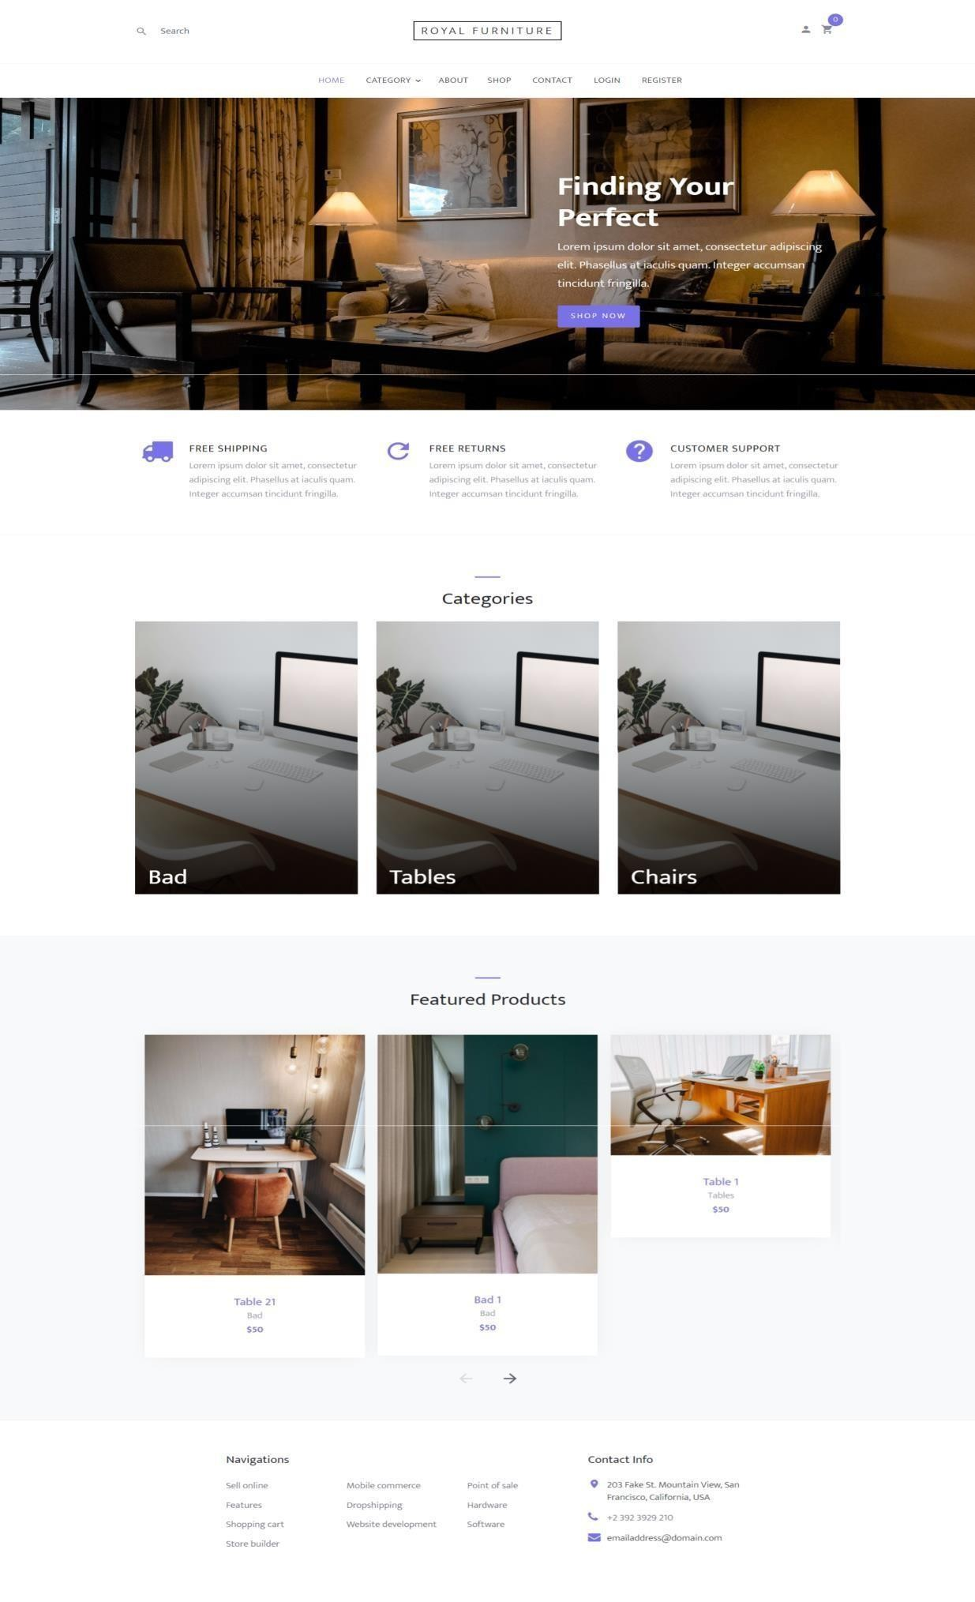

Created By : Sureliya Rutvik Royal Furniture

* **Register Page :**

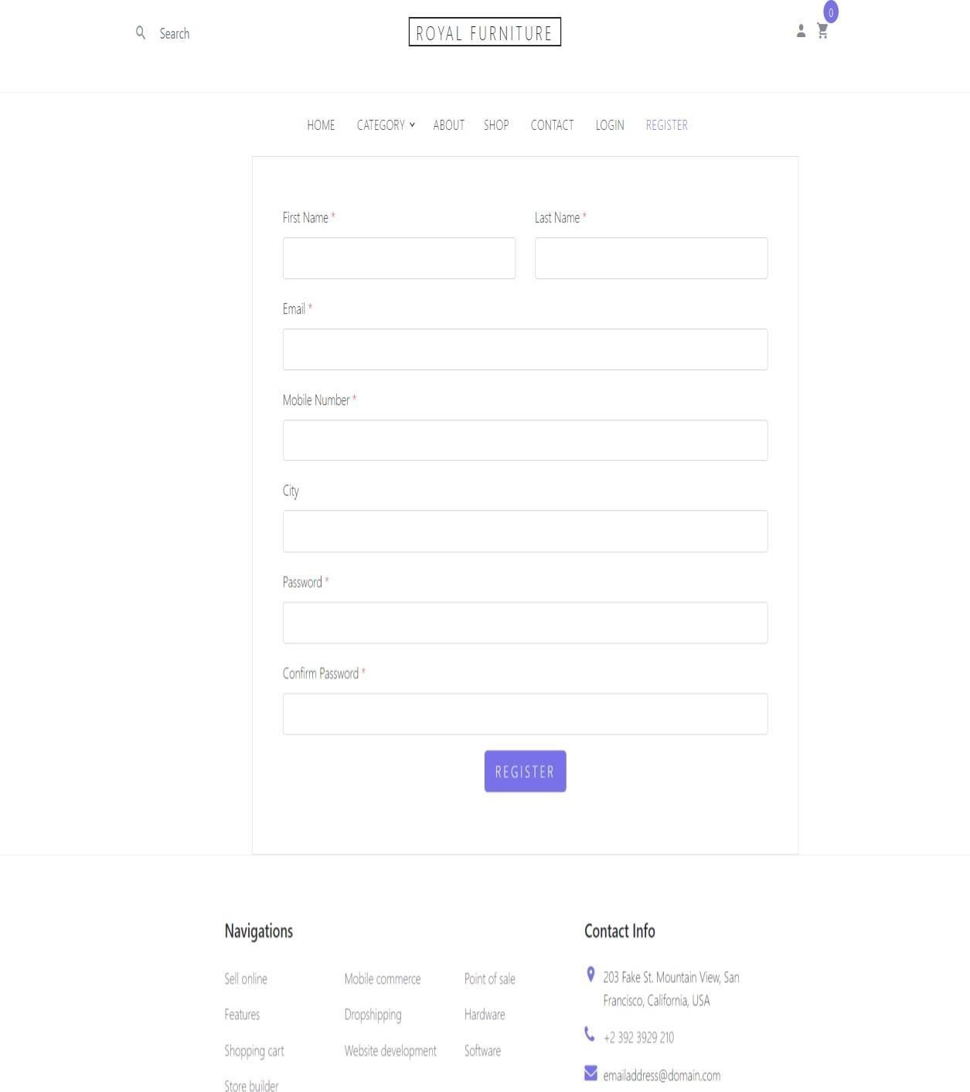

* **Login Page :**

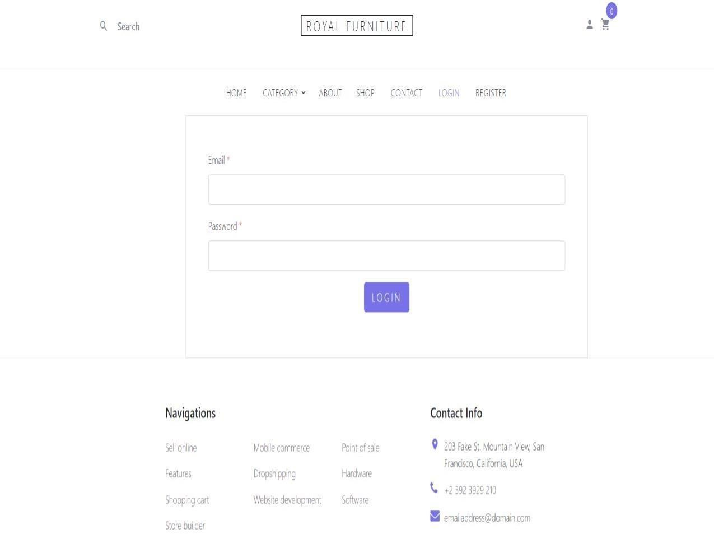

* **Contact Us Page** :

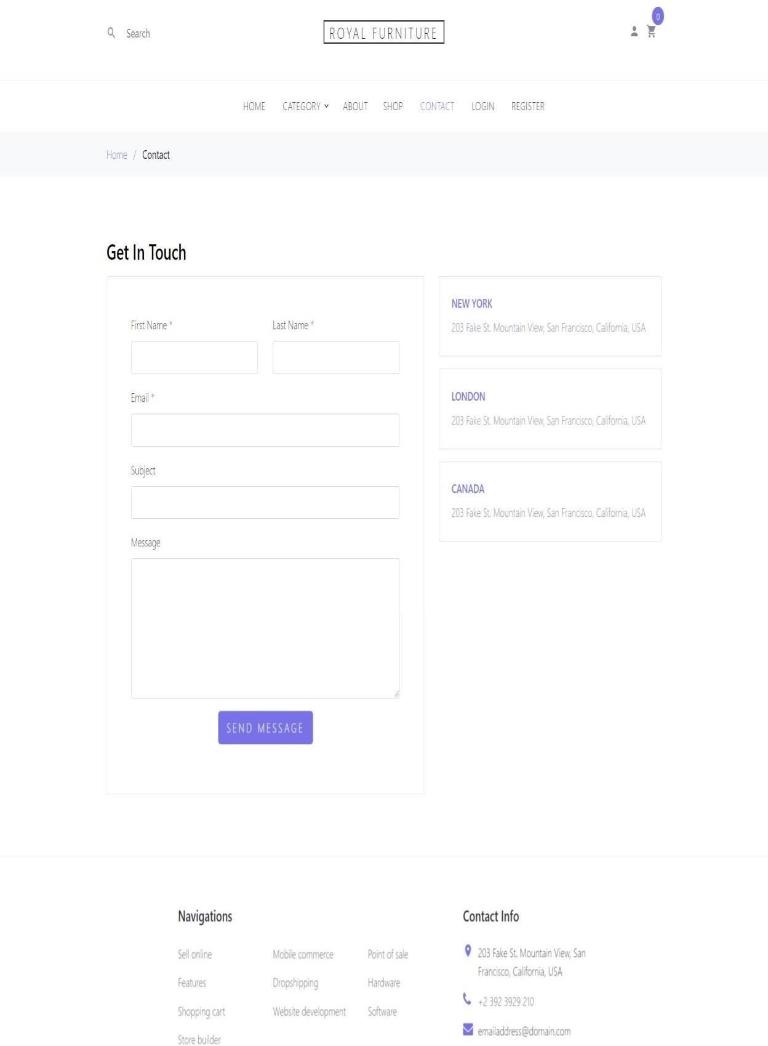

* **Shop Page :**

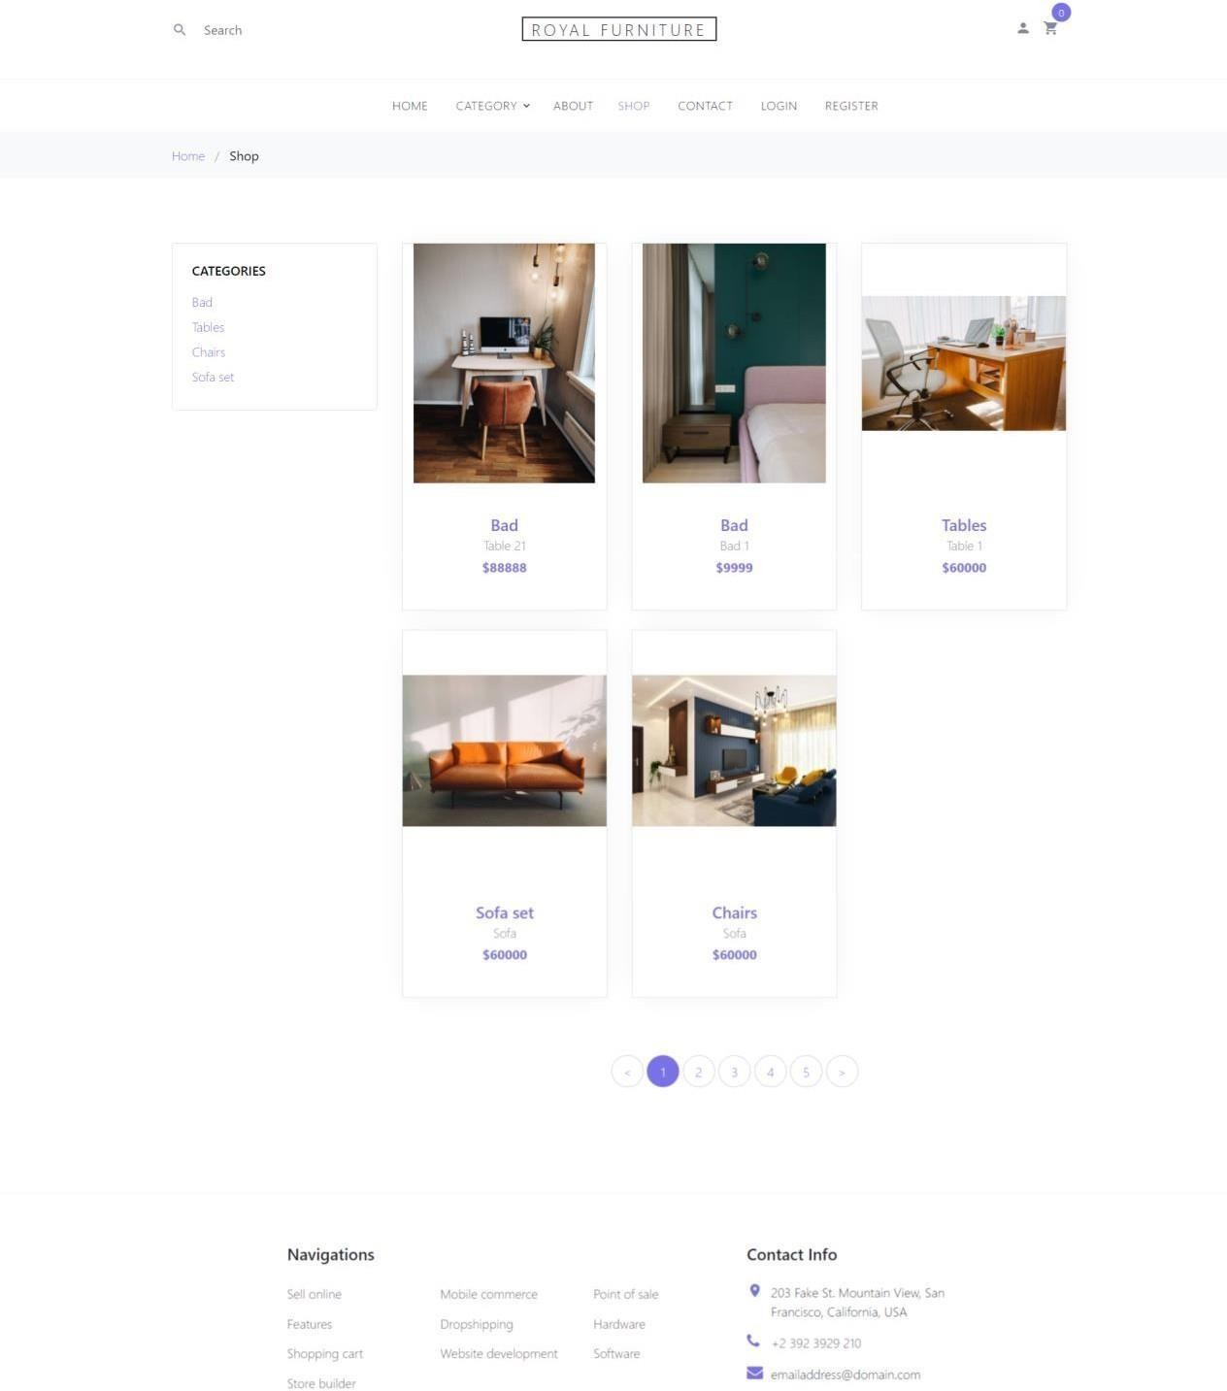

* **Product Detail :**

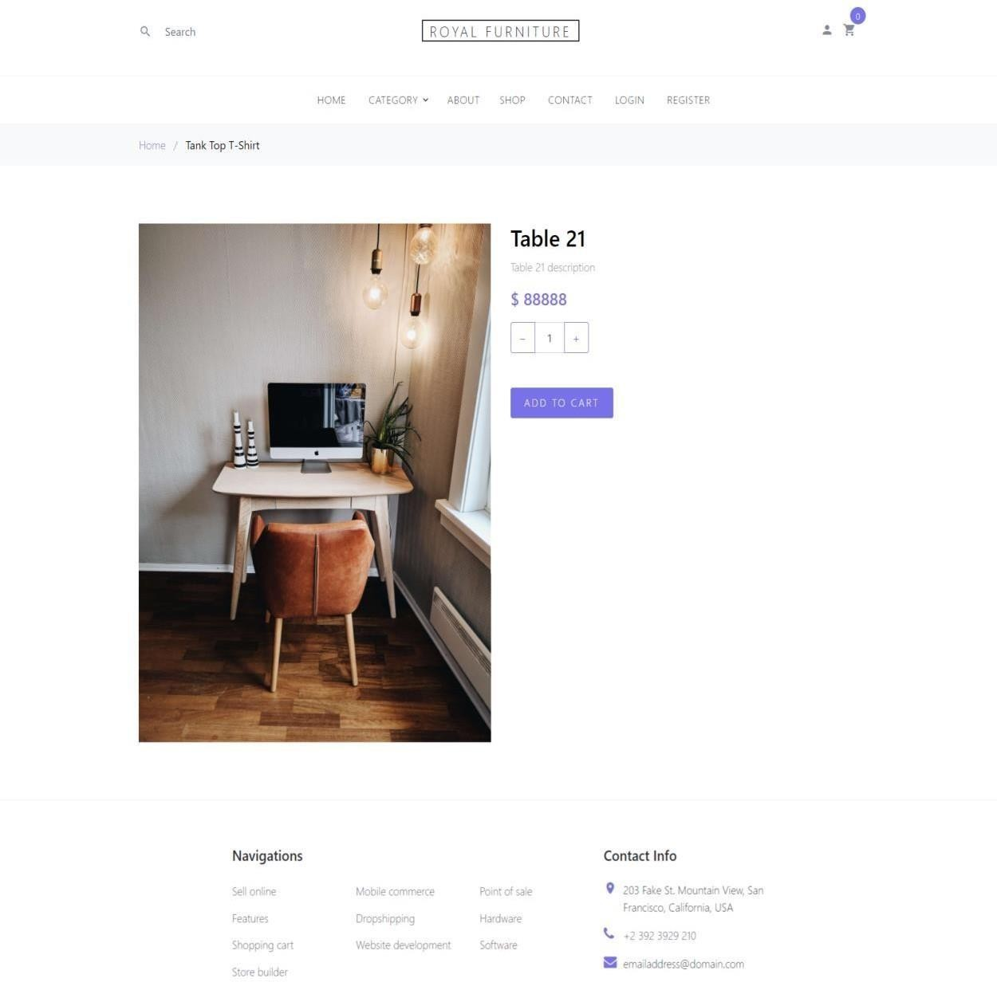

* **Admin Side :**
  + **Login Page :**

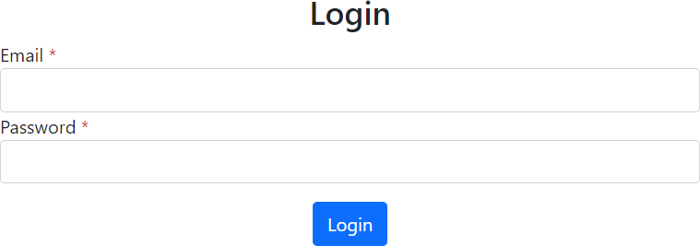

* + **Add Product :**

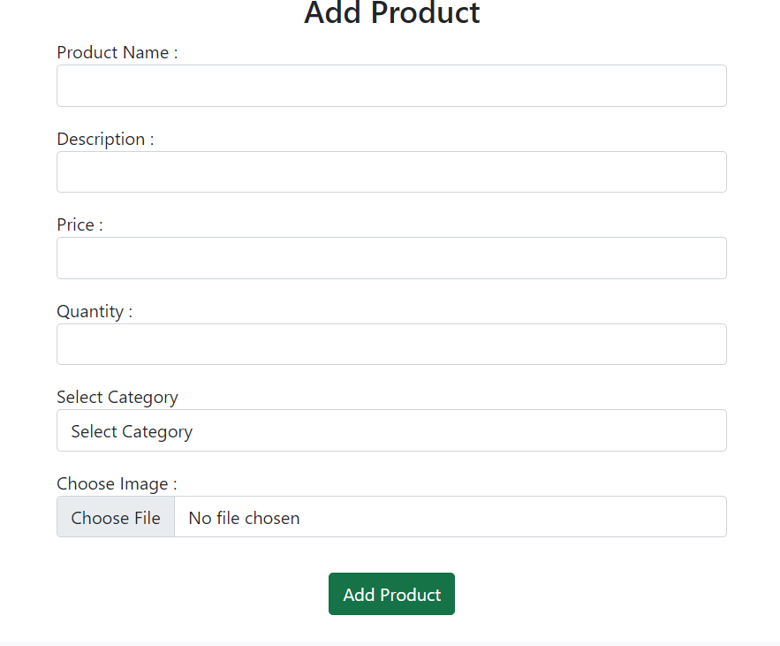

* + **Add Category :**

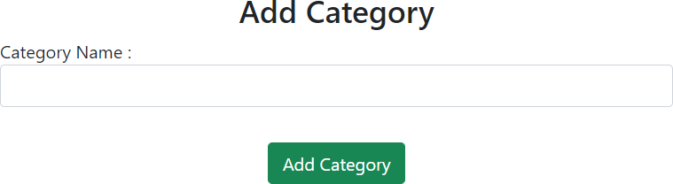

* + **All Products Page :**

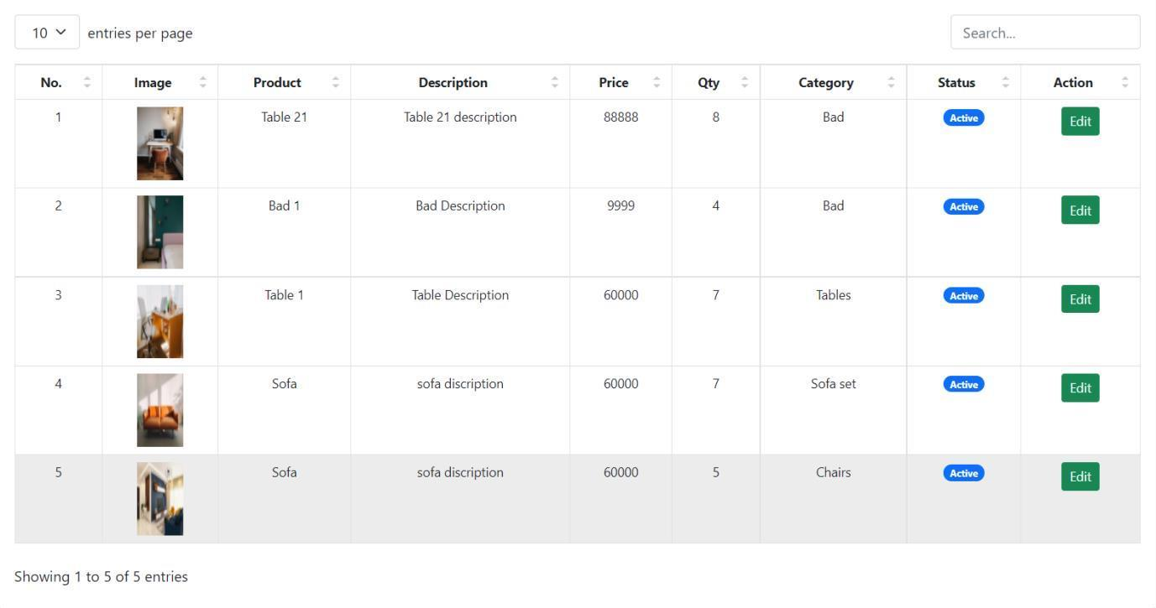

* + **All Categories :**

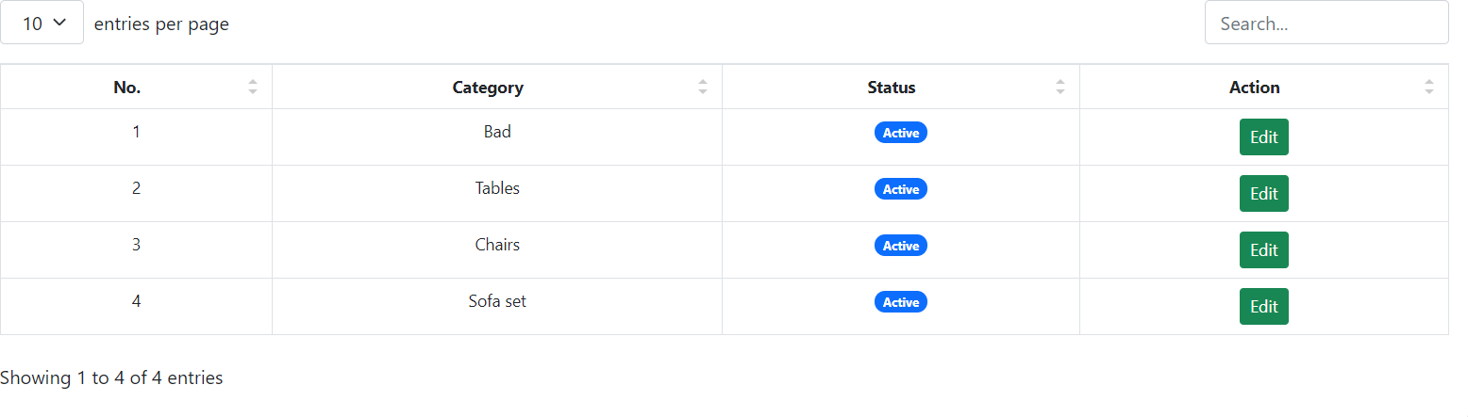

**7**

# TESTING LEVEL

* 1. **Testing:**
* Testing is one of the important steps in system development. Software Testing also provides an objective, independent view of the software to allow the business to appreciate and understand the risks at implementation of the software. Test techniques include, but are not limited to, the process of executing a program or application with the intent of finding [software](http://en.wikipedia.org/wiki/Software_bugs) [bugs.](http://en.wikipedia.org/wiki/Software_bugs)
* Software Testing can also be stated as the process of validating and verifying that a software program/application/product:
  + Meets the business and technical requirements that guided its design and development.
  + Works as expected; and
  + Can be implemented with the same characteristics.
  + Software Testing, depending on the testing method employed can be implemented at any time in the development process. However, most of the test effort occurs after the requirements have been defined and the coding process has been completed. As such, the methodology of the test is governed by the Software Development methodology adopted.
  1. **Testing Levels :**
* Tests are frequently grouped by where they are added in the software development process, or by the level of specificity of the test.
  + 1. **Unit Testing :**
       - Unit Testing refers to tests that verify the functionality of a specific section of code, usually at the function level. In an object-oriented environment, this is usually at the class level, and the minimal unit tests include the constructors and destructors.
       - These types of tests are usually written by developers as they work on code (white-box style), to ensure that the specific function is working as expected. One function might have multiple tests, to catch corner cases or other branches in the code. Unit testing alone cannot verify the functionality of a piece of software, but rather is used to assure that the building blocks the software uses work independently of each other.Unit testing is also called Component Testing.
    2. **Integration Testing :**
       - Integration Testing is any type of software testing that seeks to verify the interfaces between components against a software design. Software components may be integrated in an iterative way or all together ("big bang"). Normally the former is considered a better practice since it allows interface issues to be localized more quickly and fixed.
       - [Integration Testing w](http://en.wikipedia.org/wiki/Integration_testing)orks to expose defects in the interfaces and interaction between integrated components (modules). Progressively larger groups of tested software components corresponding to elements of the architectural design are integrated and tested until the software works as a system.
    3. **System Testing :**
       - [System Testing t](http://en.wikipedia.org/wiki/System_testing)ests a completely integrated system to verify that it meets its requirements.
  1. **Types Of Testing :**
     1. **Functional Testing :**
        + It is an approach to testing where the tests are derived from the program or component specification. The system is a black box whose behavior can only be determined by studying its inputs and the related outputs.
     2. **Structural Testing :**
        + Structural testing is an approach to testing where the tests are derived from knowledge of the software„s structure and implementation. This approach is sometimes called ‗white-box testing„ to distinguish from black –box testing.

**8**

# FUTURE WORK

* We have done analysis of this entire system till now, and in future we will develop this system as per our analysis.



* In future this application will became very user-friendly..
* We will covert this web-site into online management so that any user can access our web-site anywhere through their mobiles

**9**

**Conclusion**

* + I have developed *“Om Electronics” website* in order to overcome the difficulties in managing the existing manual system. The website has been designed effectively keeping in mind, the possible future enhancement and additional functionality; it has been designed to run in an efficient way.
  + The website is designed to be very user-friendly and interactive manner so that the user cannot find any difficulty while browsing the website. Thereby the proposed website, which is an economically, technically and operationally feasible system has overcome the deficiency that was present in the manual system.

**10**

# REFERENCES

* + - This project was impossible to be a success without the support and help from the experience guide; the books and mainly the internet really prove it for us the “Information Highway”. Everything was really easy to find out on the internet.

***Wesite :**

* [www.w3school.com](http://www.w3school.com/)
* [www.stackoveflow.com](http://www.stackoveflow.com/)
* [www.flipkart.com](http://www.flipkart.com/)
* [www.amazone.com](http://www.amazone.com/)

